CDF and pmf

Oliver

## Satellite Example

Consider launching three satellites, each with a probability of 0.9 of reaching proper orbit. We can model the **pmf** of the random variable $X$, the number of successful orbits. This will also give us the **cdf** of $X$.

x = 0:3  
 p = c((1-0.9)^3, 3*0.9*0.1^2, 3*0.9^2*0.1, 0.9^3)  
   
 ### It's easier to read if x and p are side-by-side.  
 cbind(x,p)

## x p  
## [1,] 0 0.001  
## [2,] 1 0.027  
## [3,] 2 0.243  
## [4,] 3 0.729

### We can also store the information in a data frame. Note the use of capital X.  
 X = data.frame(x,p)  
   
 ### The relationship between x and p can be plotted. Graph the pmf.  
 plot(x, p, type="p", pch=16)  
 points(x, p, type="h")

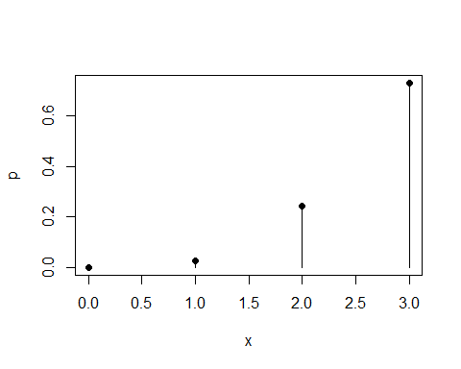

The **cdf** can be obtained from the **pmf**.

X$F = cumsum(X$p)  
 X

## x p F  
## 1 0 0.001 0.001  
## 2 1 0.027 0.028  
## 3 2 0.243 0.271  
## 4 3 0.729 1.000

plot(c(-1,X$x,4), c(0,X$F,1),type="s", ylab="F(x)", xlab="x")  
 points(X$x, X$p)

